Top Class DLP Projectors: T91 and TW90 by Toshiba – with Projection Camera and WLAN Functions
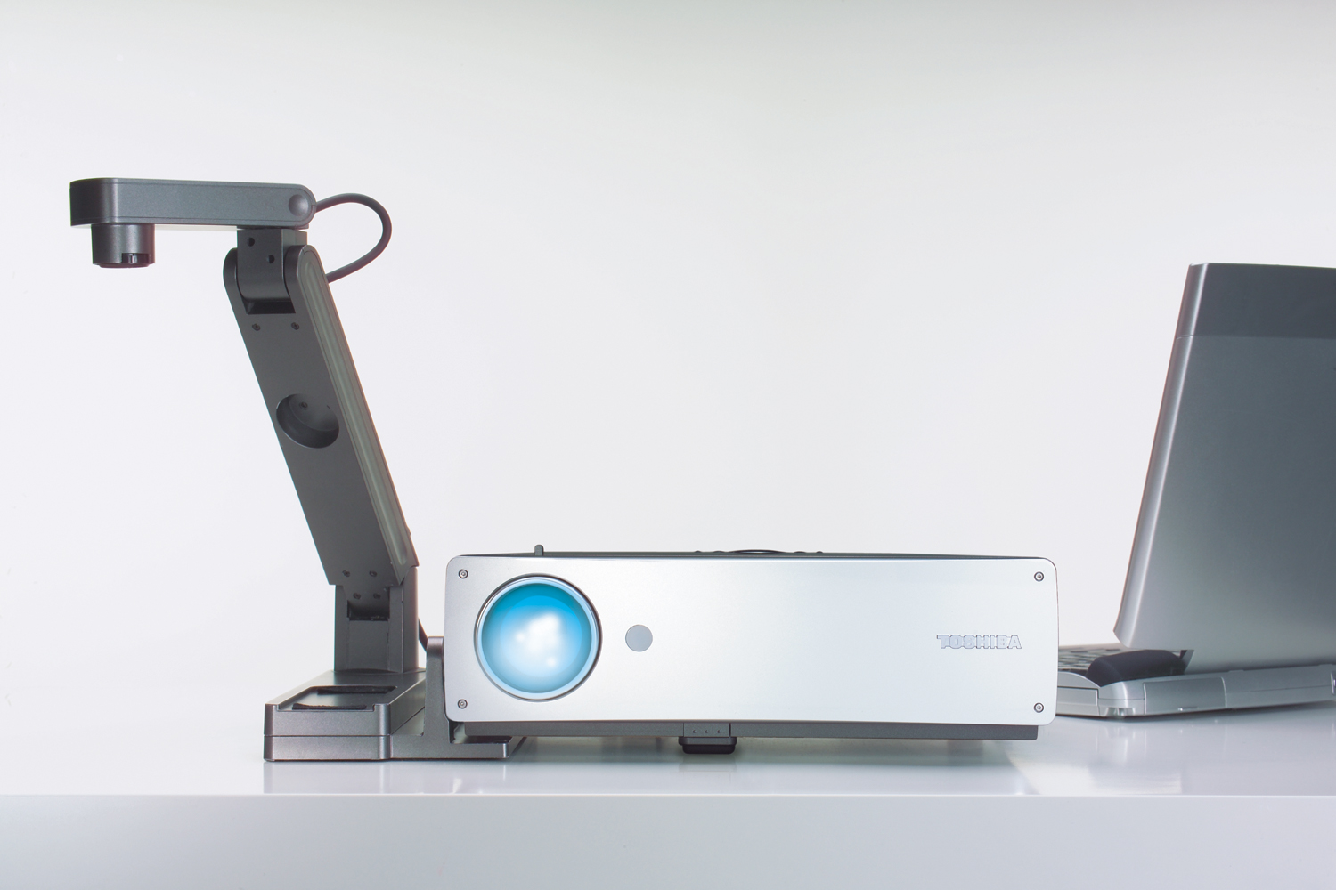

Neuss, June 2004
Toshiba Projection & Display Technology (PDT) presents the T91 and TW90, two business class DLP projectors that are further developments of the T90 launched at CeBIT 2004. The new additions to Toshiba's range also feature 2,000 ANSI lumen brightness, DLPTM technology, XGA resolution and high 2000:1 contrast ratio – key performance specs that deliver razor-sharp images and brilliant colours. With a minimum throw distance of only 1.2 m, the projectors are ideal for even the smallest conference room. The new models differ from their companion T90 in that the T91 has an additional detachable projection camera, while the TW90 features WLAN functions. The sleek trademark elegance of the aluminum design echoes both projectors' high-performance technology.
Facts & Figures
- Brightness: 2,000 ANSI lumens
- Technology: DLPTM
- Resolution: XGA
- Contrast: 2000:1
- Throw distance: from 1.2 m
- With projection camera or WLAN
- Weight TW90: 2.9 kg
Weight T91: 3.7 kg
- Practical design: all ports on the back
- Price T91: EUR 2,990 (plus VAT)
- Price TW90: EUR 2,990 (plus VAT)

High performance, flexibility and easy handling comprised the design brief for the T91 and TW90. The new models' technical features make them ideal for presentations to discerning audiences in large or small halls. Both are also equipped with a DLPTM chip for a contrast ratio of 2000:1.
Easy Operation – Smart Details
Users benefit from a host of smart details. The remote control unit (supplied) and icon-based on-screen display (OSD) make the projectors child's play to operate. Both models have a generous array of ports that maximize flexibility. Two RGB ports and two video inputs allow a variety of data sources to be connected, while audio ports cater for the acoustic side of presentations. All inputs and outputs are clearly laid out on the back of the projector, a practical feature that neatly sidesteps the frequent bugbear of cable snarl-ups at conferences. In addition, the Hard-On/Off Switch on both devices enable them to be switched off completely to save power.
T91: Detachable Projection Camera
The two new models have additional features for different applications. The T91's detachable projection camera is connected to the projector via a RGB cable to add spontaneity and flexibility to presentations. Small objects can be lit from all sides and projected onto the screen to underpin explanations in university lectures or product presentations. The camera is attached to the side of the projector, enabling slides or objects to be removed and replaced without obscuring the screen. In addition, the T91 offers all the functions of an overhead projector, so that notes or slides can be placed next to or over a PowerPoint presentation. Despite its high performance quality, the projector weighs a mere 3.7 kg and is thus eminently portable for mobile use in different locations.
TW 90 with WLAN Function
The TW90 is equipped with an integrated WLAN card, a feature with immediate appeal even to those lucky few who have never tripped over cables in a conference room! The projector is immediately ready for WLAN operation (B-Standard), allowing peer-to-peer or network-based wireless data exchange. At a mere 2.9 kg, the TW90 is also ideal for mobile use. The WLAN software required is supplied.
"Our two new T91 and TW90 projectors represent the pinnacle of our DLP projector range. Their contrast ratio of 2,000:1 and powerful brightness of 2,000 ANSI lumens deliver brilliant images in any surroundings and lighting conditions. Both high-end devices - the T91 with detachable projection camera, and the TW90 with WLAN function – have equally broad potential for educational and business applications “, says Gerd Holl, General Manager at Toshiba PDT.
Price and Availability
The T91 and the TW90 will be available from distributors and retailers from June 2004. The manufacturer's recommended sales price for both models is EUR 2,990 (plus VAT).

About Toshiba Projection & Display Technology
The Projection & Display Technology (PDT) division markets a comprehensive portfolio of data and video projectors plus a selection of LCD flat panels and plasma screens. Its offerings are intended for a broad spectrum of target groups. In the professional projectors segment, Toshiba distinguishes between the mobile class of projectors (lightweight models of up to 3 kg) and the performance class (primarily for conference applications, but also for permanent installation). PDT also focuses strongly on the forward-looking home cinema projector segment. As a systems provider, the Projection & Display Technology division is committed to developing complementary solutions for mobile presentation and wireless LAN applications.
PDT is responsible for distribution in over 50 countries in Europe, the Middle East and Africa. Toshiba employs 166,000 people worldwide and around 4200 people in Europe.
For more information, please visit us at: http://www.toshiba-europe.com/projectors

Subject to modification and errors

Toshiba T91/ TW90 – Technical Specifications
General Product Information
Available from retailers: | June 2004
Recommended sales price: | T91 : EUR 2,990 (plus VAT)  TW90 : EUR 2,990 (plus VAT)
More information: | http://www.toshiba-europe.com/projectors

Technical Specifications
Resolution | XGA (1.024 x 768) | Technology | DLPTM with 0.7 inch chip
Brightness | 2.000 ANSI lumens | Contrast ratio | 2,000:1
Horizontal frequency | 15 – 93 kHz | Vertical frequency | 50 - 85 kHz
Color reproduction | 16.7 million colors | Horizontal frequency | 15 – 85 Hz
Lens | Manual zoom, F = 2.4 – 2.65, f = 28.04 – 35.59 | Keystone correction | + / -15 degrees
Diagonal screen size | 0.63 – 6.25 meters | Throw distance | 1.2 – 10.0 meters
Lamp | 200 W | Interfaces | RS-232, USB
Computer formats | VGA, SVGA, XGA, SXGA/UXGA (compr.) | Video compatibility | PAL, SECAM, NTSC, HDTV & DTV, DVD
Inputs / Outputs
Inputs | RGB (D-sub 15 x 2), video (RCA, S-Video, Component Video), audio (stereo mini-jack, RCA x 2) | Outputs | RGB (D-sub 15), audio (stereo mini-jack x 1)
Further Specifications
Weight | 3.7 kg (T91), 2.9 kg (TW90) | Dimensions (WxHxD) | 383 x 101 x 275 mm (T91)  298 x 101 x 275 mm (TW90)
Integrated Speakers | yes | Power supply | AC 100 - 240V, 50/60Hz
T91 Detachable projection camera
Technology | ¼.2 inch CCD chip | Lens | F = 2.8, f = 2.8 mm
Resolution | 629m856 pixels | Weight | 0.9 kg
TW90 WLAN Card
Technology | Wireless LAN (IEEE802.11b), 64/128 bit encoding, WEP+

Accessories
Remote control unit with batteries, RGB cable (3 m), power cable, operating manual with cd rom, soft case, WLAN card (TW90 only), RGB cable (0.2m) T91 only

General information about the product segment and target group
Toshiba Projection & Display Technology (PDT) presents T91 and TW90, two new models for business class use featuring DLPTM technology, XGA resolution and high contrast ratio of 2000:1. Brightness of 2,000 ANSI lumens ensures perfect picture quality even under difficult lighting conditions. The T91 features a removable projection camera, while the TW90 is equipped with a WLAN card. These extras make both projectors ideal for use in conference situations and open up new fields of application for the user.

